**Bug Report :**

* **Bug ID:** 001
* **Title:** Redirected to Login Page After Email Verification Without Password Set
* **Environment:** (OS- Windows, Browser – chrome.)
* **Steps to Reproduce**:

1. Go to the registration page of the application.
2. Enter the required details (e.g., Name, Email).
3. Submit the registration form.
4. Check your email inbox for the verification email.
5. Open the verification email.
6. Click on the verification link in the email.
7. After clicking the verification link, you are redirected to the login page.
8. On the login page, two options are displayed - "Enter your email" , "Enter your password"

* **Expected Result**: Redirected to a password creation page to set up a password
* **Actual Result:** User redirected to login page where two options are displayed.
* **Screenshots:**

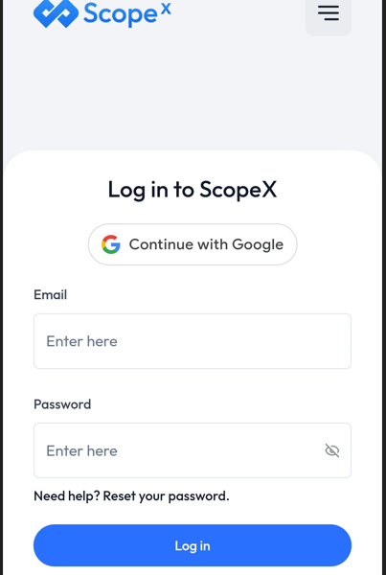

* **Severity:** High
* **Bug ID:** 002
* **Title:** Filter should be selected .
* **Environment:** (OS- Windows, Browser – chrome.)
* **Steps to Reproduce**:

1. Login to <https://scopex.money/>
2. Navigate to Dashboard
3. Scroll down to analytics
4. Click on ‘3M’ from filter by month
5. Check the graph value

* **Expected Result:** Upon clicking on 3M filter should be selected
* **Actual Result:** Filter is not getting selected
* **Screenshot:**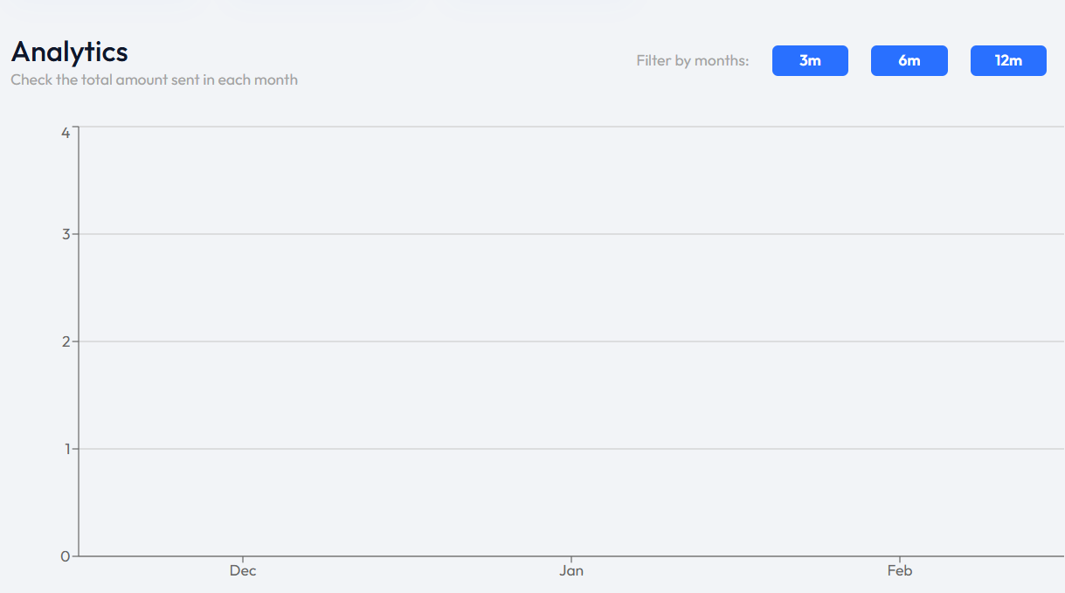
* **Severity:** High
* **Bug ID:** 003
* **Title:** Register button is enabled when user already logged in
* **Environment:** (OS- Windows, Browser – chrome.)
* **Steps to Reproduce**:

1. Login to <https://scopex.money/>
2. Navigate to Home
3. Check the register button

* **Expected Result:** Register button should be disabled if user already logged in
* **Actual Result:** Register button is enabled
* **Screenshots/Videos:**



* **Severity:** High
* **Bug ID:** 004
* **Title:** Account number should have limit.
* **Environment:** (OS- Windows, Browser – chrome.)
* **Steps to Reproduce**:

1. Login to <https://scopex.money/>
2. Navigate to Recipient
3. Add bank account number

* **Expected Result:** Bank account number should have limit
* **Actual Result:** There is not limit
* **Screenshots/Videos:**

* **Severity:** High
* **Bug ID:** 005
* **Title:** Recipient Not Removed from UI Until Refresh
* **Environment:** (OS- Windows, Browser – chrome.)
* **Steps to Reproduce**:

1. Login to <https://scopex.money/>
2. Navigate to Recipient list
3. Remove recipient
4. Check recipient not removed
5. Refresh the page.

* **Expected Result:** Recipient should be removed without refresh the page.
* **Actual Result:** Recipient Not Removed from UI Until Refresh
* **Screenshots/Videos:**

* **Severity:** High